Document for Vue Js Cordova Leaflet Project:

Reference:

<https://itnext.io/make-hybrid-platform-cordova-vue-webpack-2fb7031c4f9b>

Create the Cordova project.

cordova create hybrid-base com.f1lt3r.hybridbase

Create the Vue.js-Webpack project.

vue init webpack hybrid-base

You will be asked: ? Target directory exists. Continue? you should answer “Yes” to this as the directory was created in the previous Cordova step.

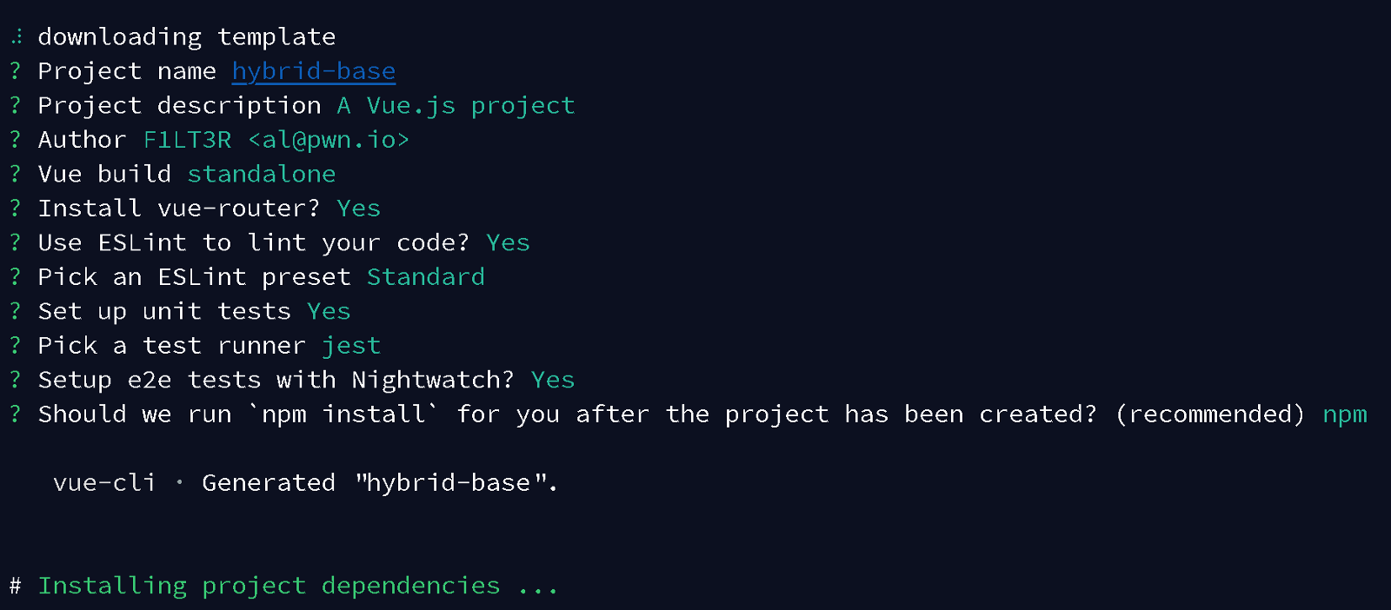

Remove the contents of the Cordova ./www directory, as we will be building this content with WebPack instead.

We will need to leave the ./www directory as this is the code that Cordova will bundle onto your mobile device.

cd hybrid-base  
rm -r www/*

Open the WebPack config file: ./config/index.js and update the the following paths:

* Change the index and assestsRoot paths to point to Cordova’s ./wwwdirectory so that the code for your app is built to ./www/dist before being packaged into your mobile device.
* Change the assetsPublicPath value to be an empty string ''. This will allow your phone to serve the view via the file:/// protocol. This is important because you will not be running a web server on your mobile device (usually).

Open ./config.xml and update Cordova’s WebView entry point.

<content src=”dist/index.html” />

Build your app’s distribution package using:

npm run build

open the Vue.js ./index.html  and update your Content-Security-Policy meta tag to allow local web sockets. You can do this by adding: connect-src 'self' ws:;. This will allow WebPack to know when to rebuild and reload your code in the web browser preview. This should happen every time you make a change to your source code.

<meta http-equiv=”Content-Security-Policy” content=”default-src ‘self’ data: gap: [https://ssl.gstatic.com](https://ssl.gstatic.com/) ‘unsafe-eval’; style-src ‘self’ ‘unsafe-inline’; media-src *; img-src ‘self’ data: content:; connect-src ‘self’ ws:;”>

Now

npm run dev

cordova platform add android

cordova run android